How to Export Raw Data from Loan > Reports > CCL Raw Data

- Go to Loan > Reports > CCL Raw Data

- Click the record count and set display limit to ‘Unlimited’
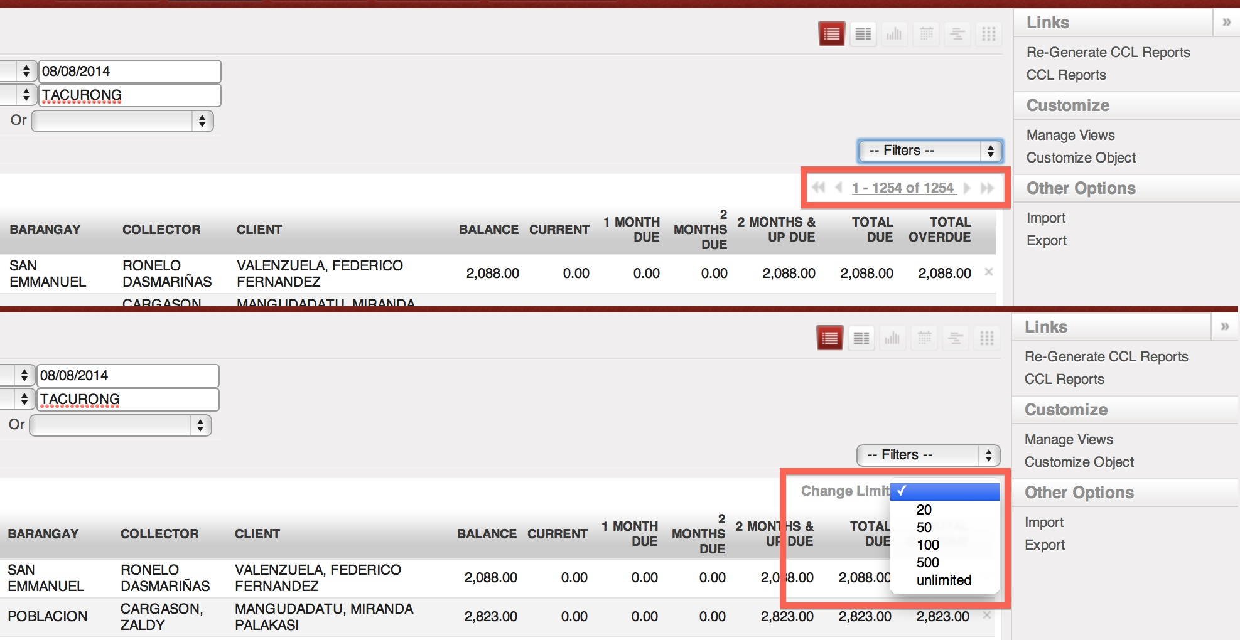

- Setup filters
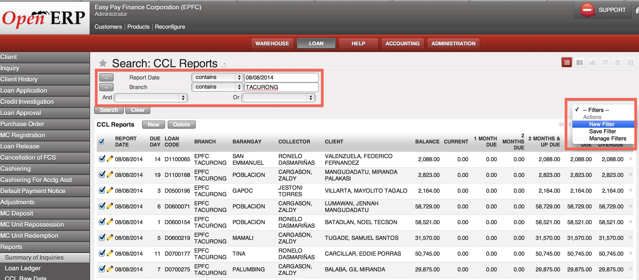

- Select all records then click ‘Export’ from Other Options in the right panel
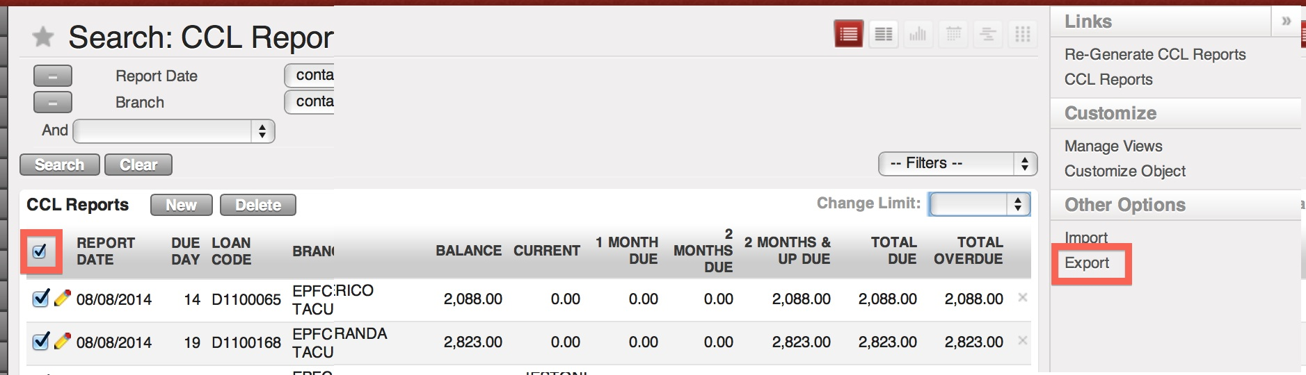

- Select specific fields to retrieve
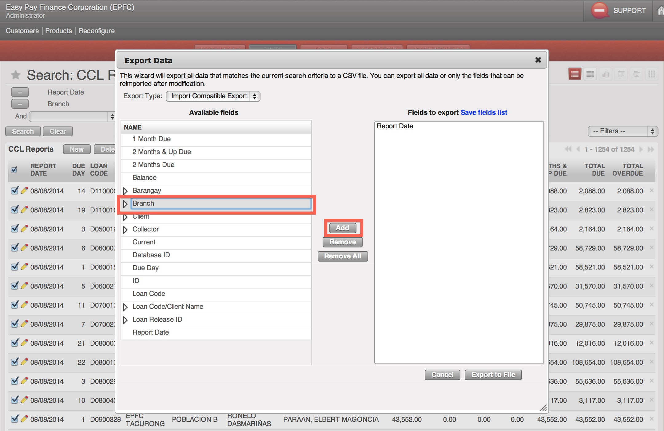

- You may opt to save field set for succeeding exports

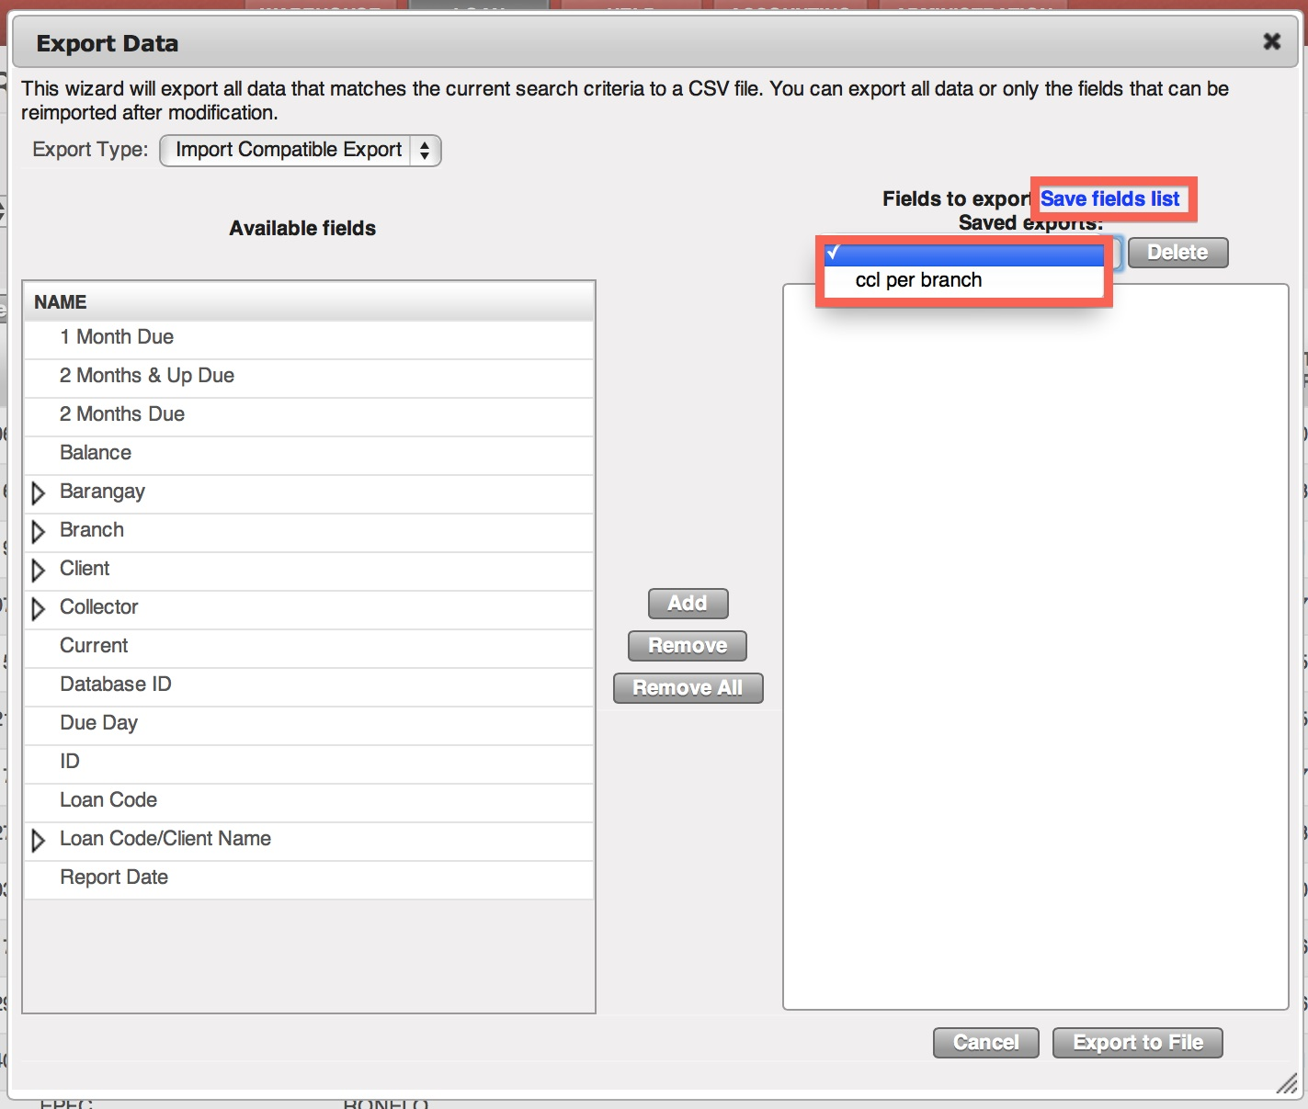

- Click ‘Export to File’ to download the .csv file

